**Assignment/Project Day 3**

**PROJECT 1:**

Create a windows instance

IP: 13.232.212.187

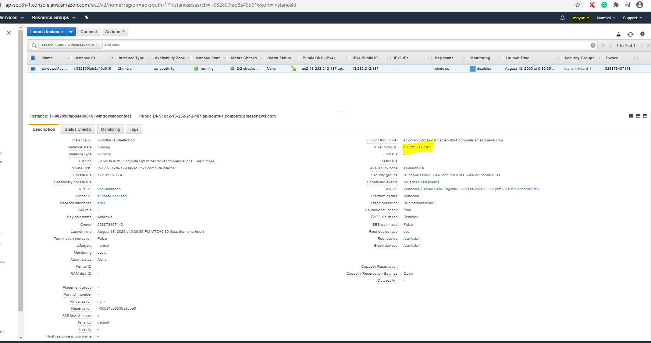

Launch the Windows instance using RDP

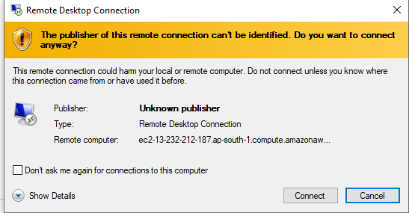

Install IIS web server using Powershell ISE

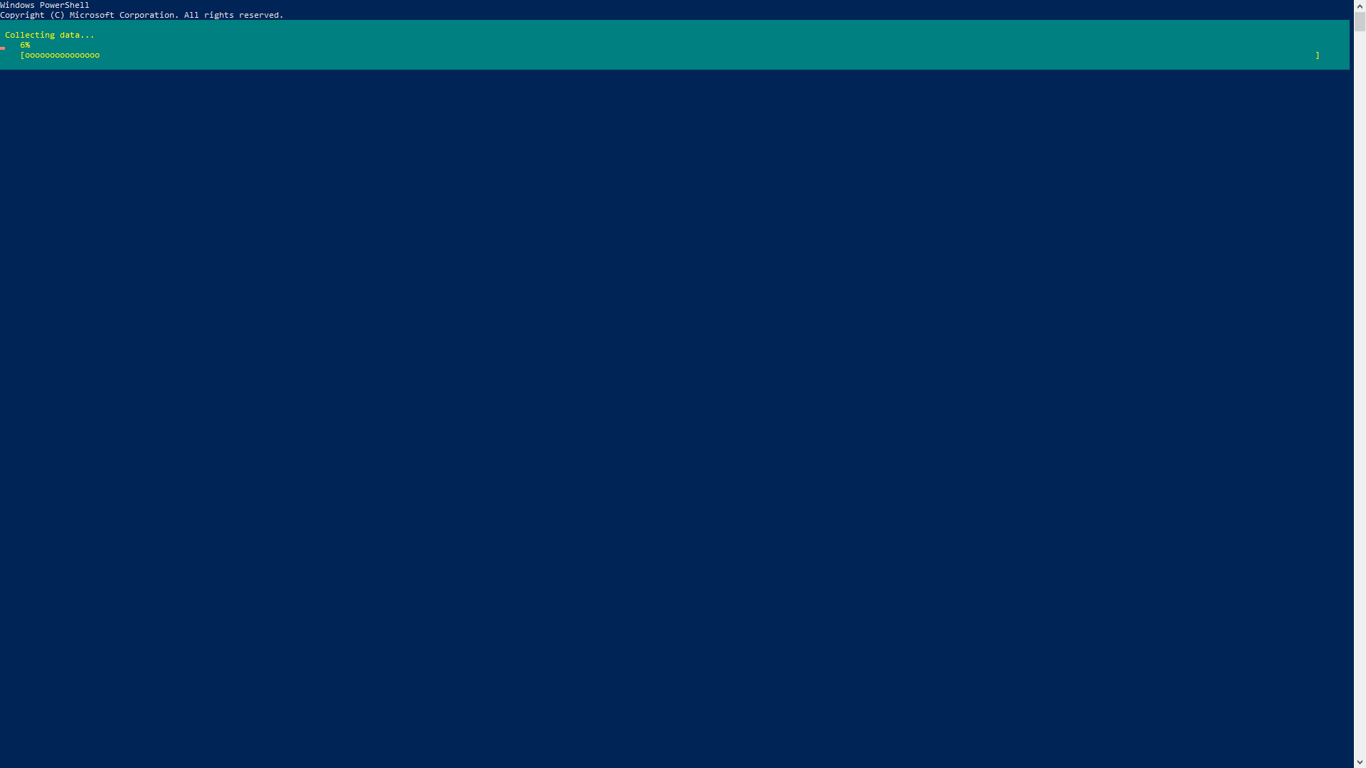

Verify successful installation of IIS Web Server

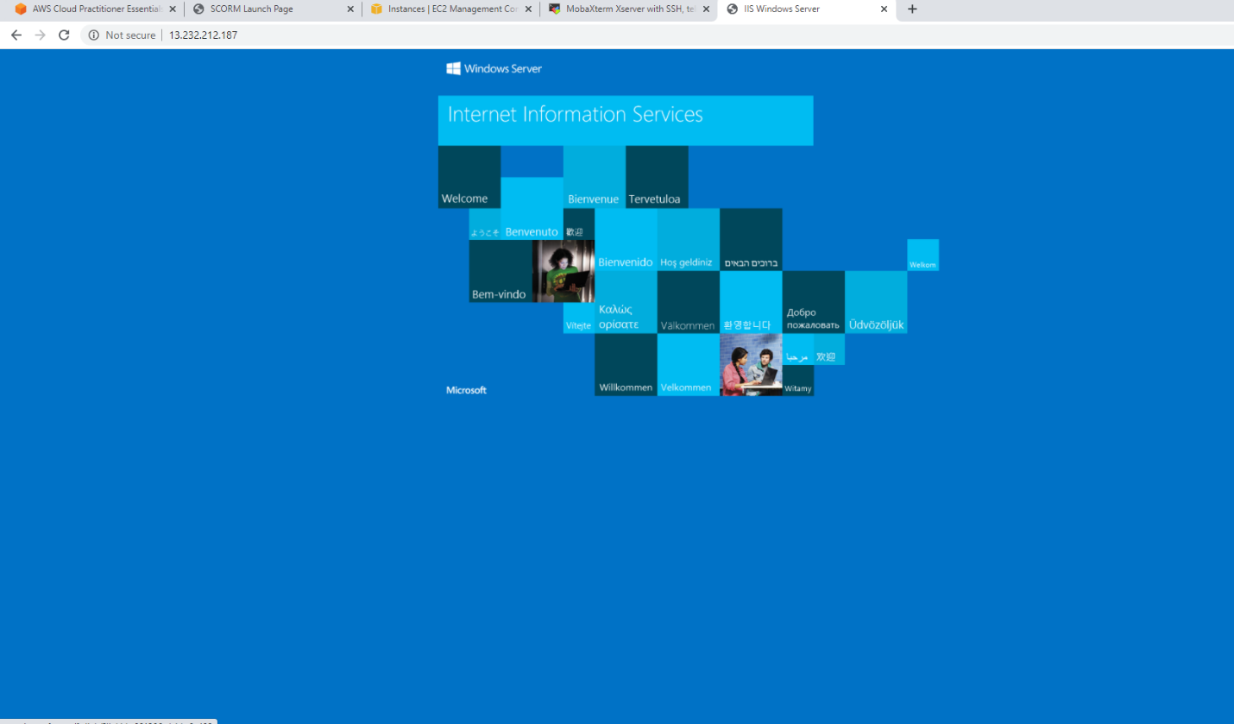

Create a windows instance using AMI :Ubuntu Server 18.04 LTS (HVM)

IP:13.292.97.70

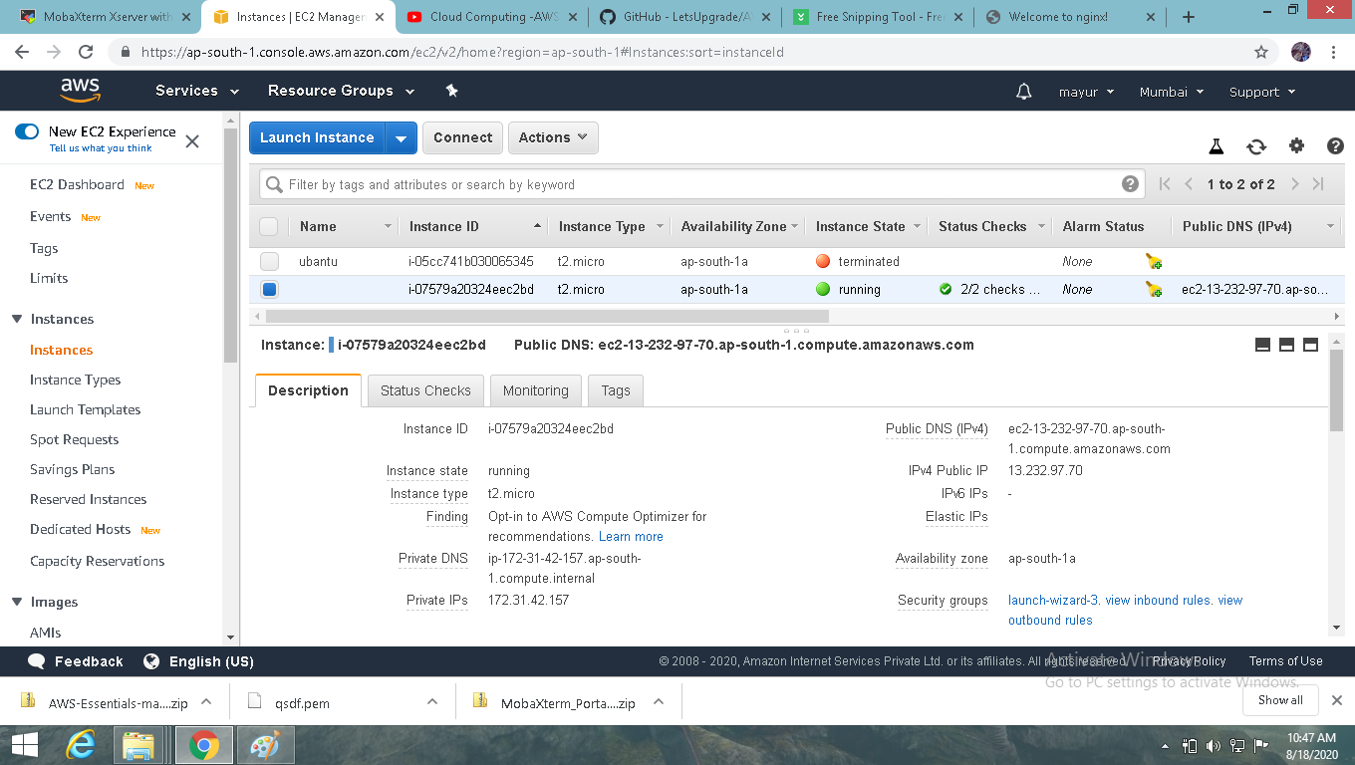

Install ngnix web server using bash

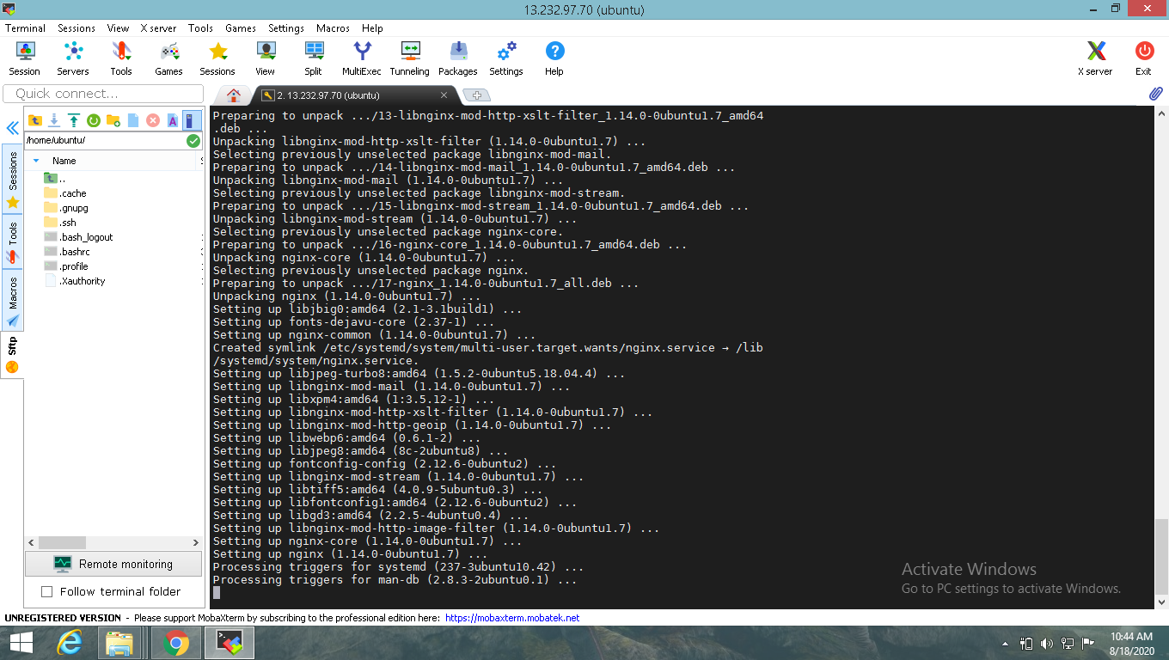

Verify successful installation of ngnix

